Lesson 01 – Hello World Challenge

All coding assignments will be name Challenge (Lesson Number) _ (Problem Number). java unless otherwise stated. EX: Challenge 01_01.java

Add a comment in the first couple line of your code with your name and the date.

All written assignments will be name Challenge (Lesson Number) _ (Problem Number).txt or Challenge (Lesson Number) _ (Problem Number).docx

In the header of the doc or first few line (txt), put your name and the date.

Comment all code in meaningful ways that would help other, not knowing about coding, understand what is going on.

This is a challenge assignment. This ‘assignment’ will be more challenging than the normal lab. There is to be no peer collaboration for challenge assignments.

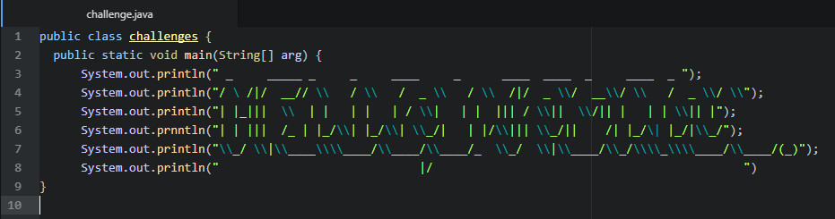

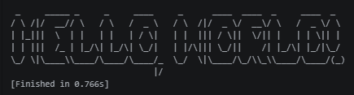

Oh no! Our challenge.java isn’t working! Find the issues in the code. There is more than one error in this Java class. You don’t need to get all of them. Each one you find nets you one extra credit point on Assignment One.